Ceph对象存储添加osd导致业务io被长时间block问题

问题描述
某项目对象存储对象个数超过1亿3千万，单个bucket接近9千万对象
ceph集群存在1个object omap个数超过5千万，添加osd时会导致业务io长时间block，影响业务正常运行
ceph health detail
HEALTH_WARN noout,noscrub,nodeep-scrub flag(s) set; 1 large omap objects
OSDMAP_FLAGS noout,noscrub,nodeep-scrub flag(s) set
LARGE_OMAP_OBJECTS 1 large omap objects
1 large objects found in pool 'clusterB-zone.rgw.buckets.index'
Search the cluster log for 'Large omap object found' for more details.
导致这个告警是由于Ceph默认配置
osd_deep_scrub_large_omap_object_key_threshold= 2000000 # 200万

环境信息
对象存储multisite，2套集群，A集群正常，B集群有个告警
A集群
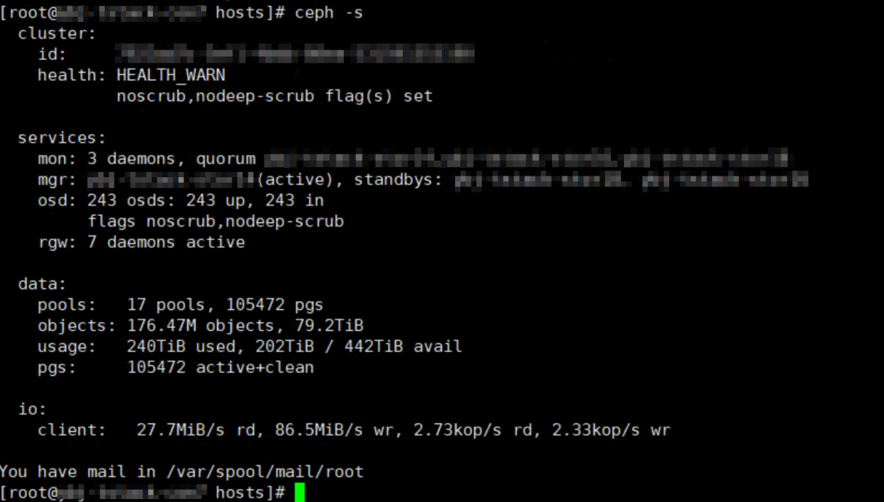
B集群
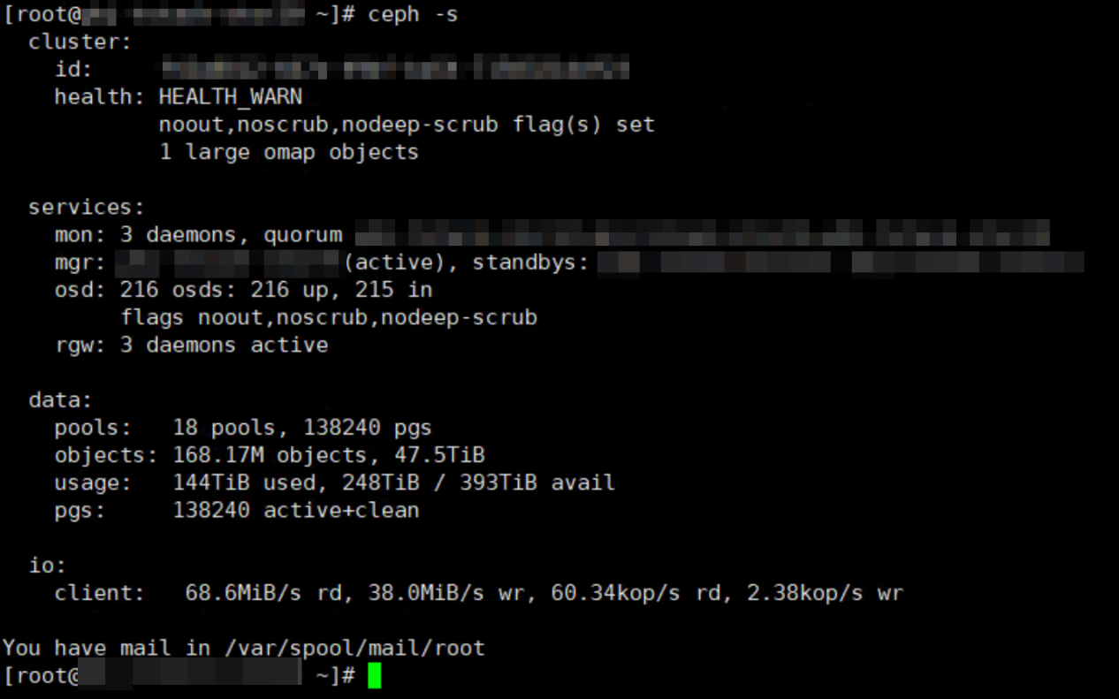

问题分析
找到存在large omap object的pgid
准备一个脚本vim large_obj.py
import json
import rados
import rbd

ceph_conf_path = '/etc/ceph/ceph.conf'
rados_connect_timeout = 5

class RADOSClient(object):
def __init__(self,driver,pool=None):
self.driver = driver
self.client, self.ioctx = driver._connect_to_rados(pool)
def __enter__(self):
return self
def __exit__(self, type_, value, traceback):
self.driver._disconnect_from_rados(self.client, self.ioctx)

class RBDDriver(object):
def __init__(self,ceph_conf_path,rados_connect_timeout,pool=None):
self.ceph_conf_path = ceph_conf_path
self.rados_connect_timeout = rados_connect_timeout
self.pool = pool
def _connect_to_rados(self, pool=None):
client = rados.Rados(conffile=self.ceph_conf_path)
try:
if self.rados_connect_timeout >= 0:
client.connect(timeout=
self.rados_connect_timeout)
else:
client.connect()
if self.pool == None:
ioctx = None
else:
ioctx = client.open_ioctx(self.pool)
return client, ioctx
except rados.Error:
msg = "Error connecting to ceph cluster."
client.shutdown()
raise msg

def _disconnect_from_rados(self, client, ioctx=None):
if ioctx == None:
client.shutdown()
else:
ioctx.close()
client.shutdown()

class cmd_manager():
def get_large_omap_obj_poolname(self):
with RADOSClient(RBDDriver(ceph_conf_path,rados_connect_timeout)) as dr:
result = ''
cmd = '{"prefix": "health", "detail": "detail", "format": "json"}'
result = dr.client.mon_command(cmd,result)
if result[0] == 0:
res_ = json.loads(result[1])
if res_["checks"]['LARGE_OMAP_OBJECTS']:
return res_["checks"]['LARGE_OMAP_OBJECTS']['detail'][0]['message'].split("'")[1]
else:
return False
def get_pg_list_by_pool(self,poolname):
with RADOSClient(RBDDriver(ceph_conf_path,rados_connect_timeout)) as dr:
result = ''
cmd = '{"prefix": "pg ls-by-pool", "poolstr": "' + poolname + '", "format": "json"}'
result = dr.client.mon_command(cmd,result)
if result[0] == 0:
return json.loads(result[1])
else:
return False

cmd_ = cmd_manager()
poolname = cmd_.get_large_omap_obj_poolname()
print "Large omap objects poolname = {0}".format(poolname)
res = cmd_.get_pg_list_by_pool(poolname)
for i in res:
if i["stat_sum"]["num_large_omap_objects"] != 0:
print "pgid={0} OSDs={1} num_large_omap_objects={2}".format(i["pgid"],i["acting"],i["stat_sum"]["num_large_omap_objects"])
查找large omap所在的pg
python large_obj.py
Large omap objects poolname = clusterB-x-zone.rgw.buckets.index
pgid=30.91 OSDs=[141, 215, 127] num_large_omap_objects=1
查询pg详情
ceph pg 30.91 query
{
"state": "active+clean",
"peer_info": [
{
"peer": "215",
"pgid": "30.91",
"stats": {
"last_deep_scrub_stamp": "2020-10-02 02:28:35.978219",
"stat_sum": {
"num_bytes": 0,
"num_objects": 1,
"num_large_omap_objects": 1
},
"up": [
141,
215,
127
],
"acting": [
141,
215,
127
],
"blocked_by": [],
"up_primary": 141,
"acting_primary": 141
}
}
]
}
找到pg所在的3个osd，查看omap文件总大小，osd上的omap过多导致文件很大19G，正常的osd omap文件夹不超过6G
[root@xxxxx ~]# ssh xxxxx
Warning: Permanently added 'xxxxxxx,x.x.x.x' (ECDSA) to the list of known hosts.
Last login: Thu May 13 15:51:32 2021 from x.x.x.x
[root@xxxxx ~]# du -sh /var/lib/ceph/osd/ceph-215/current/omap/
16G /var/lib/ceph/osd/ceph-215/current/omap/
[root@xxxxx ~]# logout
Connection to xxxxx closed.
[root@xxxxx ~]# ssh xxxxx
Warning: Permanently added 'xxxxx,x.x.x.x(ECDSA) to the list of known hosts.
Last login: Thu May 13 16:55:45 2021 from x.x.x.x
[root@xxxxx ~]# du -sh /var/lib/ceph/osd/ceph-127/current/omap/
18G /var/lib/ceph/osd/ceph-127/current/omap/
[root@xxxxx ~]# logout
Connection to xxxxx closed.
[root@xxxxx ~]# ssh xxxxx
Warning: Permanently added 'xxxxx,x.x.x.x(ECDSA) to the list of known hosts.
Last login: Fri May 14 18:57:35 2021 from x.x.x.x
[root@xxxxx ~]# du -sh /var/lib/ceph/osd/ceph-141/current/omap/
19G /var/lib/ceph/osd/ceph-141/current/omap/
[root@xxxxx ~]#
查找ceph 所有节点log搜索Large omap object found，找到一个桶分片omap对象过大，超过5千万条数据，占用空间大约11.5G
2021-01-26 02:43:53.055519 osd.141 osd.141 x.x.x.x:6802/668087 88512 : cluster [WRN] Large omap object found. Object: 30:8905fecf:::.dir.6210e962-feba-4520-8b2e-6e02ed30540c.131681127.2:head Key count: 53957025 Size (bytes): 12445786687
查询可疑对象所在osd
ceph osd map clusterB-zone.rgw.buckets.index .dir.6210e962-feba-4520-8b2e-6e02ed30540c.131681127.2
osdmap e109640 pool 'clusterB-x-zone.rgw.buckets.index' (30) object '.dir.6210e962-feba-4520-8b2e-6e02ed30540c.131681127.2' -> pg 30.f37fa091 (30.91) -> up ([141,215,127], p141) acting ([141,215,127], p141)
对比2个集群，分析该对象是由于之前执行桶分片操作时残留的索引
.dir.6210e962-feba-4520-8b2e-6e02ed30540c.131681127.2，分别在2个集群上找
A集群查询没有该索引对象
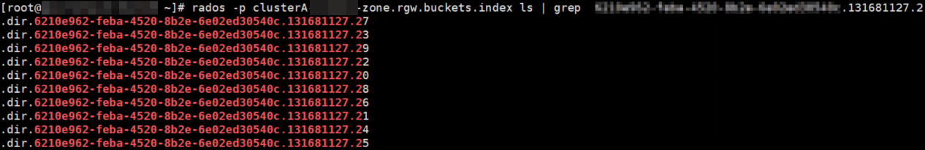
B集群查询索引对象存在，但是桶bucket-iep-usc当前并未使用该索引对象
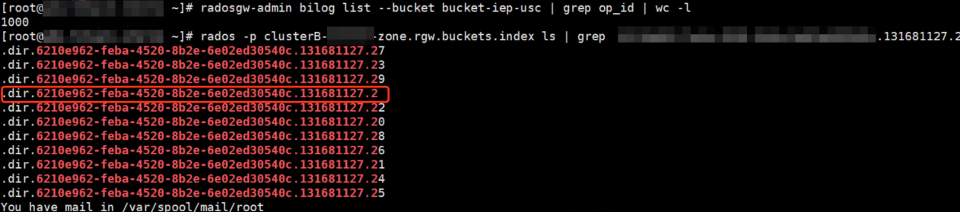解决办法
删除残留索引对象可临时解决该问题
rados rm .dir.6210e962-feba-4520-8b2e-6e02ed30540c.131681127.2 -p clusterB-x-zone.rgw.buckets.index
操作过程中需要注意：
- 在删除omap数据过程中，由于rocksdb操作时间过长会出现osd down的现象，等删除完osd会自动恢复为up。
- 删除完再次检查osd omap大小，可以看到明显减小，在合理范围内；
- 删完数据集群的告警one large omap objects并不会自动消失，手动执行deep-scrub即可，ceph pg deep-scrub 30.91
- 另外在实施过程中遇到备份数据耗时过长问题，通过命令行大约每秒只能备份100条数据，因此不建议通过命令行备份
mkdir objomap.bak
cd objomap.bak
poolname="clusterB-x-zone.rgw.buckets.index"
objname=".dir.6210e962-feba-4520-8b2e-6e02ed30540c.131681127.2"
rados -p $poolname listomapkeys ${objname} > ${objname}.key.omap
for id in `cat ${objname}.key.omap`;do rados -p $poolname getomapval ${objname} $id $id;done
使用脚本备份，测试110万条数据1分钟完成，5千万条数据预估45分钟备份完成，参考脚本
#!/usr/bin/env python
# -*- coding: UTF-8 -*-
import os
from rados import (Rados, ReadOpCtx, ObjectNotFound)

MAX_SIZE = 100000

def backup_obj_omap(pool_name, object_name):
cluster = Rados(conffile='/etc/ceph/ceph.conf')
cluster.connect()
ioctx = cluster.open_ioctx(pool_name)
start_str = ""
count = 0
with ReadOpCtx(ioctx) as read_op_inst:
while True:
iter, _ = ioctx.get_omap_vals(read_op_inst, start_str, "", MAX_SIZE)
try:
ioctx.operate_read_op(read_op_inst, object_name)
except ObjectNotFound:
return
data = list(iter)
if len(data) == 0:
break
dir_name = str(count)
os.makedirs(dir_name)
for k, v in data:
# print(k, v)
f = open(os.path.join(str(count), k), "w")
f.write(v)
f.close()
start_str = k
count += 1

if ioctx is None:
cluster.shutdown()
else:
ioctx.close()
cluster.shutdown()

if __name__ == '__main__':
backup_obj_omap('images', 'test')
恢复脚本:参考备份脚本修改

建议
1.修改告警阈值osd_deep_scrub_large_omap_object_key_threshold=200000，避免当omap数据过多时导致业务不可用
由于缺省告警阈值单个object 2million k/v太高，当具有大量omap数据的存储桶索引执行recovery时会阻塞客户端访问该桶内数据，最新代码已降低该值到20万，详见:
https://tracker.ceph.com/issues/40583
该patch已合入到L版v12.2.13
https://github.com/ceph/ceph/pull/29175
2.修改桶配额，限制用户一直往同一个桶内上传过多对象，从业务层进行优化，对象过多的情况考虑分开存放到多个桶内。

参考
https://access.redhat.com/solutions/5703641
https://cloud.tencent.com/developer/article/1400660

